ASSIGNMENT 8
AIM:
To design an NMOS amplifier with voltage divider biasing.
CIRCUIT:
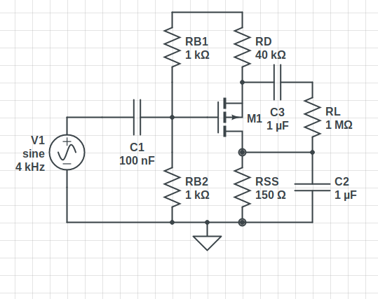

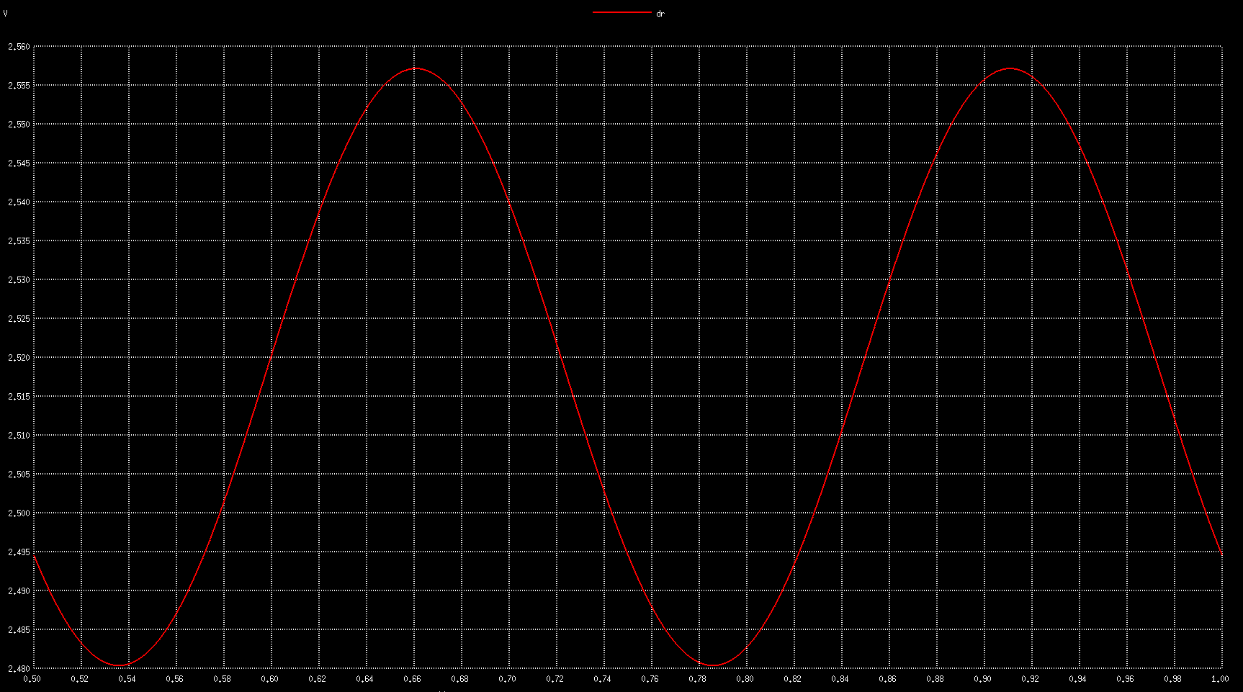
OBSERVATIONS: Without Load resistance.
Vout vs t

Data
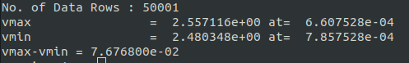

We see that Vin = 50mVpp, we have Vout ~76.mVpp, hence we have a gain of ~1.536

With RL = 1MOhm
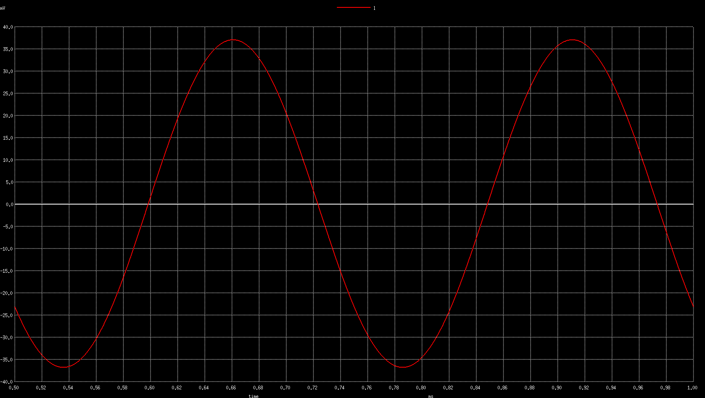
Data -
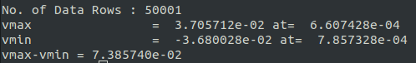

Gain ~1.4772

RL = 50KOhm
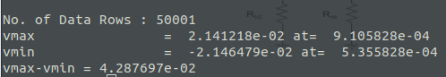

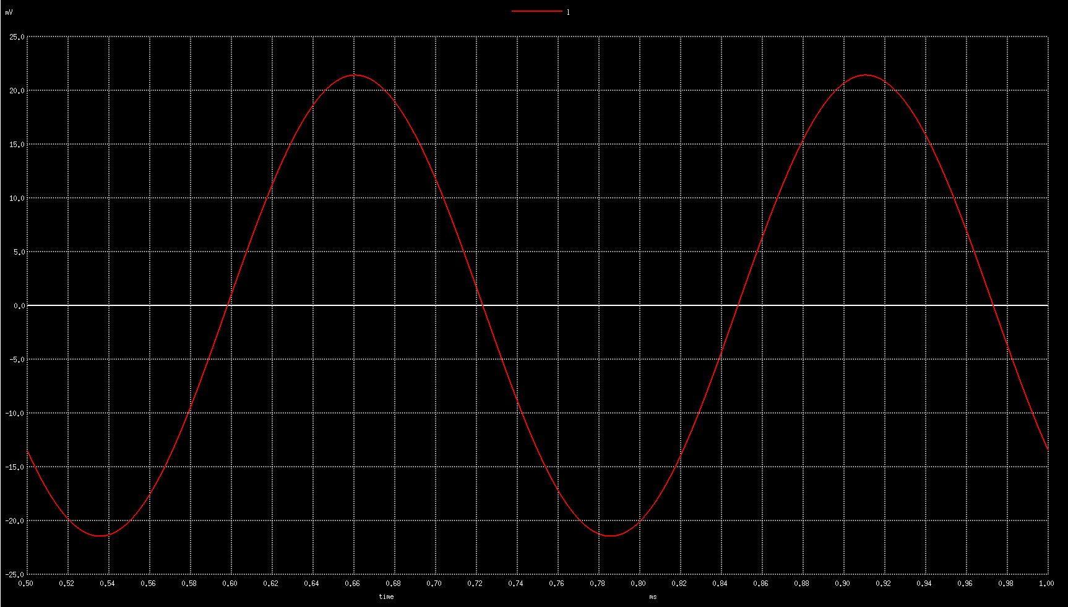
Gain ~0.8576

RL = 5KOhm

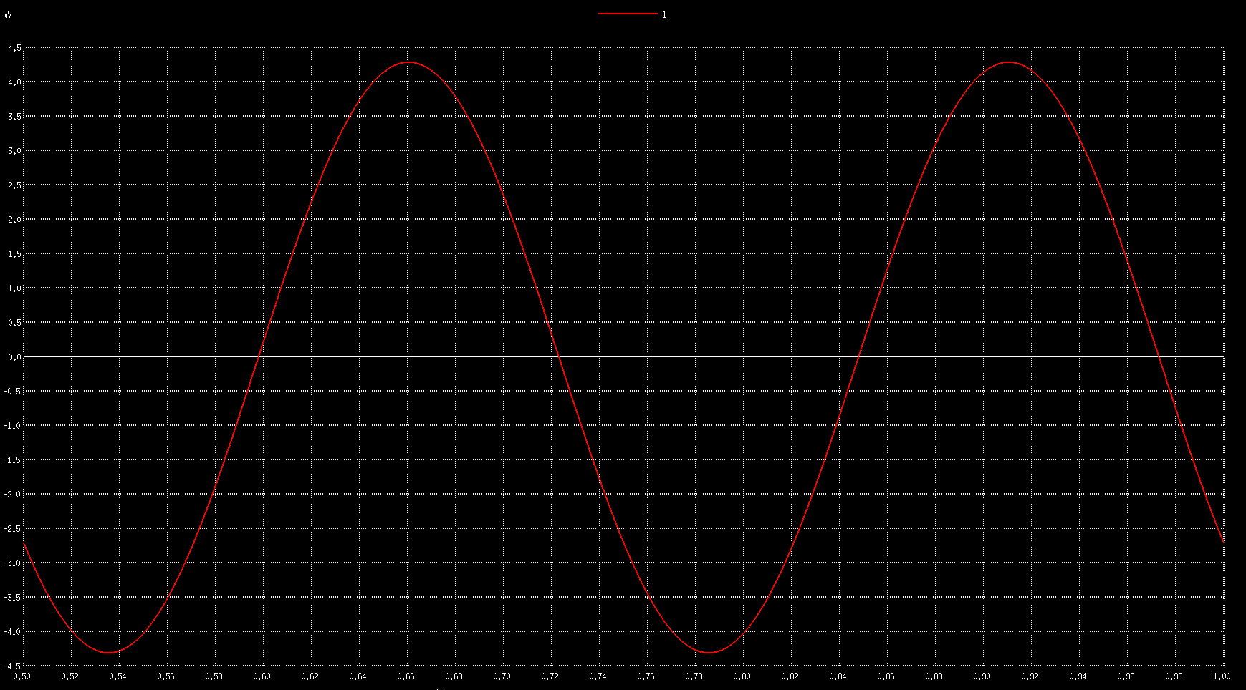
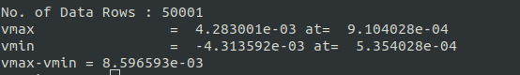
Data

Gain ~ 0.172
RL = 1KOhm
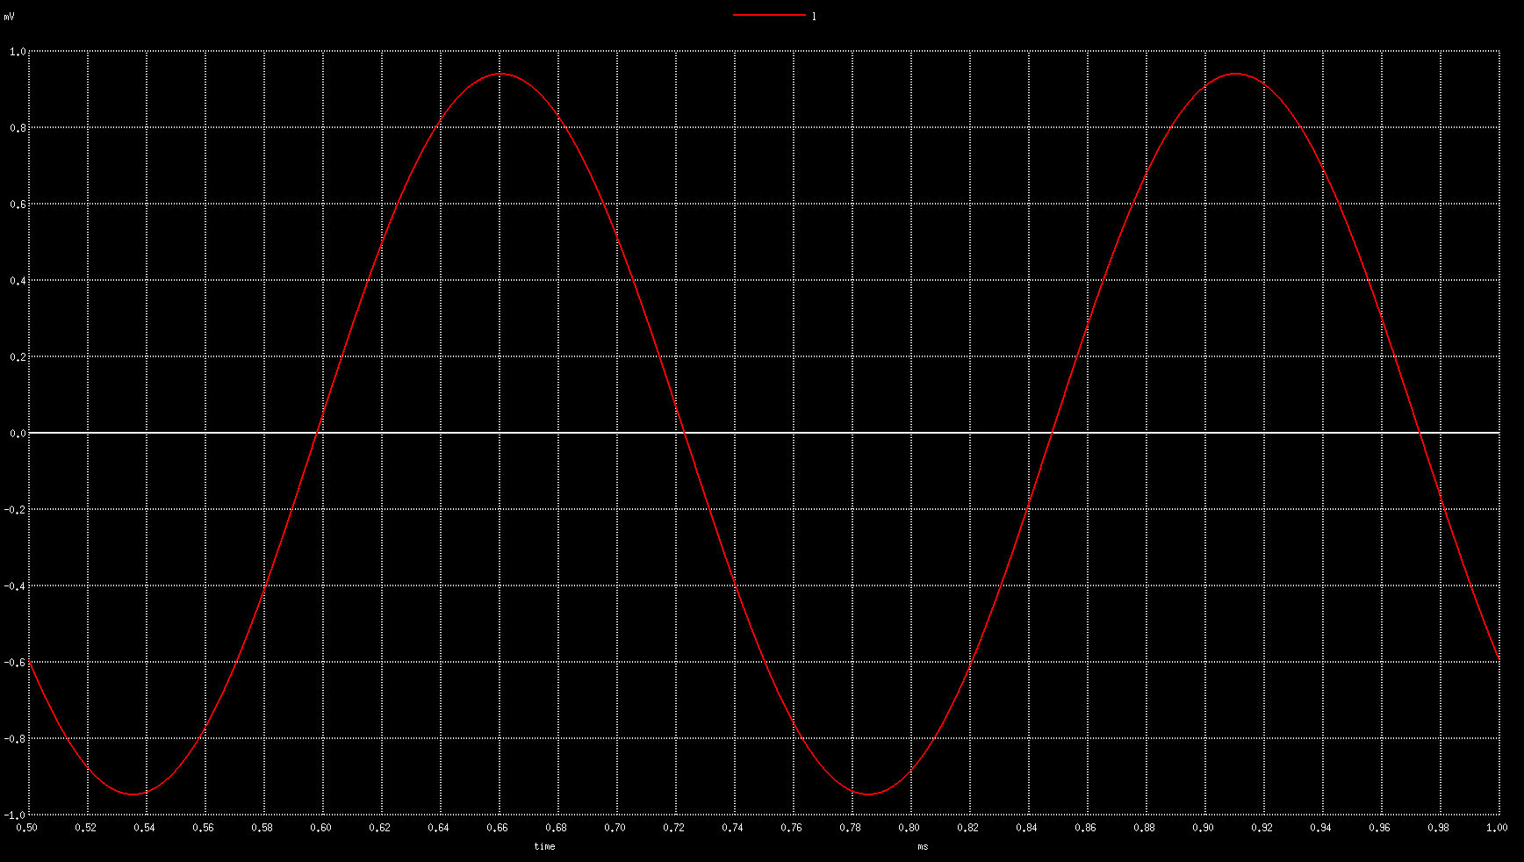
Data
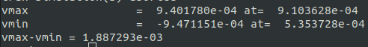

Gain ~ 0.378

CONCLUSION:
We find that for lower Load Resistance (RL), the gain decreases.

